

AMERICAN INTERNATIONAL UNIVERSITY-BANGLADESH (AIUB)
FACULTY OF SCIENCE AND TECHNOLOGY
DEPARTMENT OF COMPUTER SCIENCE AND ENGINEERING
COMPUTER GRAPHICS
Semester: Spring 2025-26
Section: L
PROJECT
Urban Life in Motion

Supervised By
RAHNUMA TASMIN

Submitted by
Name | ID
Adham Samin | 23-53329-3
Topu Roy | 23-53318-3
Al Rahit | 23-53316-3
Utsho Karmakar | 23-53327-3

Group Member Information
Member Name | ID | Assigned Area
Adham Samin | 23-53329-3 | Sky, clouds, rain, rain clouds, sun, moon, welcome page, and related transitions
Topu Roy | 23-53318-3 | Road, cars, traffic light, and traffic transitions
Al Rahit | 23-53316-3 | Buildings, building-related scene details, wind wave transition
Utsho Karmakar | 23-53327-3 | Ground, trees, lamp posts, flags, and wind wave transition

Table of Contents

- Introduction
- Proposal
- Schematic Diagram
- List of Objects
- Functions to Represent the Objects
- Interactive Functions
- Iterative Functions and Transitions
- Task Assignment and Codes of Functions
- Conclusion

INTRODUCTION
The project “Urban Life in Motion” is a 2D computer graphics animation project developed using OpenGL and GLUT. The main objective of this project is to represent a modern urban environment with moving and interactive elements. The scene includes buildings, roads, cars, traffic lights, trees, flags, lamp posts, sky, clouds, sun, moon, rain, and weather transitions.
The project focuses on applying basic computer graphics concepts such as drawing primitives, object composition, animation, keyboard interaction, color variation, and object transformation. Different objects are created using OpenGL primitives like GL_QUADS, GL_TRIANGLES, GL_POLYGON, GL_LINES, and GL_POINTS.
The project also includes interactive controls. The user can start the project from a welcome screen, control the traffic light, switch between day and night, turn rain on or off, and control wind direction. The project code uses separate drawing functions, global variables, update functions, and keyboard functions, following the faculty-provided OpenGL structure.

Proposal
The proposed project is an animated city environment that shows urban life with both environmental and traffic-based activities. The city scene contains roads, cars, buildings, greenery, weather effects, and interactive controls.
The main idea is to create a lively urban environment where:
- Cars move on the road.
- Traffic lights control car movement.
- The sky changes between day and night.
- Rain can be turned on or off.
- Clouds and rain clouds appear in the sky.
- Wind affects trees, flags, and cloud movement.
- A welcome page appears before the main animation starts.
The project demonstrates how simple OpenGL drawing techniques can be combined to create a complete animated scene.

SCHEMATIC DIAGRAM
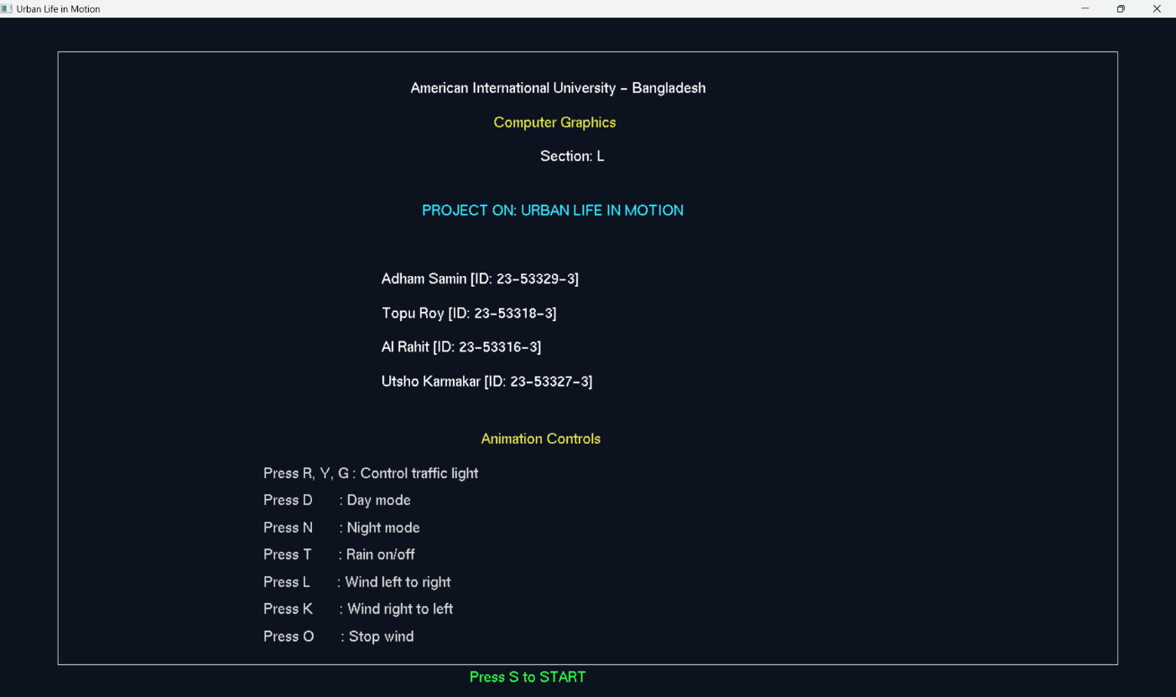
Figure 01: Welcome Page
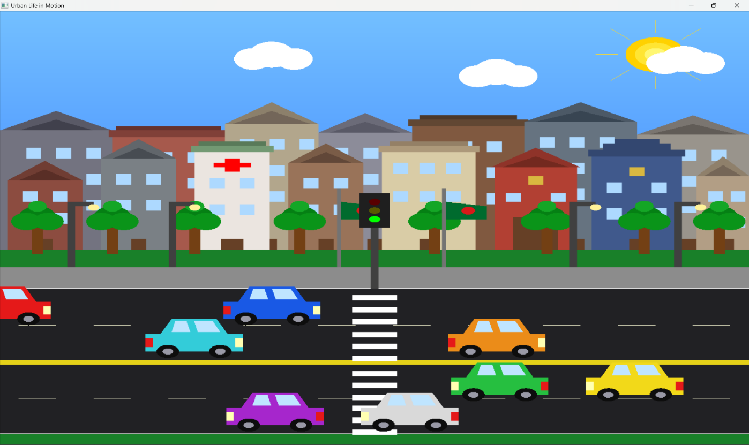
Figure 02: Project main Interface

List of Objects
The project includes the following objects:

- Welcome / Start screen
- Project title text
- Group member information text
- Animation control instruction text
- Sky
- Stars
- Sun
- Sun rays
- Moon
- Clouds
- Rain clouds
- Rain drops
- Wind effect lines
- Buildings
- Hospital building
- School building
- Fire service station
- Police station
- Building doors
- Building windows
- Building roofs
- Ground / grass area
- Trees
- Tree trunks
- Tree leaves
- Lamp posts
- Lamp lights
- Bangladesh flags
- Flag poles
- Road
- Footpath
- Road borders
- Middle divider
- Lane markers
- Zebra crossing
- Traffic light pole
- Traffic light box
- Red traffic signal
- Yellow traffic signal
- Green traffic signal
- Cars
- Car bodies
- Car cabins
- Car windows
- Car headlights
- Car tail lights
- Car wheels

Functions to Represent the Objects
These are the main functions used to draw or represent the objects in the project:
Function Name | Object / Purpose
drawText() | Draws text on the screen
drawStartScreen() | Draws the welcome/start screen
drawSky() | Draws the sky background and gradient
drawStars() | Draws stars during night
drawSunMoon() | Draws the sun, sun rays, and moon
drawClouds() | Draws moving clouds
drawRainClouds() | Draws dark rain clouds
drawRain() | Draws rain drops
drawWindEffect() | Draws wind direction lines
drawBuildings() | Draws all buildings and building details
drawGround() | Draws the grass/ground area
drawWindTree() | Draws a single wind-affected tree
drawTrees() | Draws all trees
drawLampPosts() | Draws lamp posts and lights
drawFlags() | Draws Bangladesh flags
drawRoad() | Draws road, footpath, divider, lane markers, and zebra crossing
drawTrafficLight() | Draws traffic light pole, box, and signal lights
drawSingleCar() | Draws one car
drawCars() | Draws all cars
drawCircle() | Helper function for circular objects
drawZebraLane() | Helper function for zebra crossing lanes

Interactive Functions
Interactive functions are used to control animation through keyboard input.
Main Interactive Function
void handleKeypress(unsigned char key, int x, int y)
This function handles all keyboard controls.
Keyboard Controls
Key | Action
S | Starts the project from the welcome screen
R | Changes traffic light to red
Y | Changes traffic light to yellow
G | Changes traffic light to green
Enter | Pauses or resumes car movement
D | Activates day mode
N | Activates night mode
T | Turns rain on or off
L | Wind blows from left to right
K | Wind blows from right to left
O | Stops wind

Iterative Functions and Transitions
Iterative functions are used to update object positions and transition values repeatedly. In this project, the main iterative function is:
void update(int value)
This function is repeatedly called using:
glutTimerFunc(20, update, 0);
Transitions handled in update()
Transition / Animation | Description
Cloud movement | Clouds move continuously across the sky
Wind-based cloud movement | Clouds move faster depending on wind direction
Rain transition | Rain intensity increases or decreases smoothly
Rain drop movement | Rain drops fall downward and reset after leaving the screen
Day/night transition | Sky changes gradually between day and night
Car movement | Cars move on road lanes
Traffic transition | Cars respond to red, yellow, and green traffic signals
Wind wave transition | Trees and flags bend/wave based on wind direction

Task Assignment and Codes of Functions

- Adham Samin

AssignedTask:
Sky, clouds, rain, rain clouds, sun, moon, first welcome page, and related transitions.
Functions written / used for assigned task:
- void drawText(float x, float y, const char *text);
- void drawStartScreen();
- void initRain();
- void startRainSound();
- void stopRainSound();
- void drawSky();
- void drawStars();
- void drawSunMoon();
- void drawClouds();
- void drawRainClouds();
- void drawRain();
Transition / interaction code related to task:
- update()
- handleKeypress()
Specific contribution:
- Created the welcome/start page.
- Displayed project information and controls.
- Created the sky background.
- Created sun and moon objects.
- Created cloud objects.
- Created rain cloud system.
- Created rain drop animation.
- Added rain sound.
- Added rain on/off control.
- Added smooth rain transition.
- Added cloud speed change with wind.
- Added day/night environment support.

- Topu Roy

Assigned Task:
Road, cars, traffic light, and traffic transitions.
Functions written / used for assigned task:
- drawCircle();
- drawRoad();
- drawZebraLane();
- drawTrafficLight();
- drawSingleCar();
- drawCars();
- moveRightLane();
- moveLeftLane();
- getGreenOrYellowSpeed();
Transition / interaction code related to task:
- update()
- handleKeypress()
Specific contribution:
- Created road and footpath.
- Created road divider and lane markings.
- Created zebra crossing.
- Created traffic light.
- Created cars.
- Added car movement.
- Added traffic signal control using red, yellow, and green keys.
- Added car stopping logic at red light.
- Added slow movement during yellow light.
- Added pause/resume control for cars.

- Utsho Karmakar
Assigned Task:
Ground, trees, lamp posts, flags, and wave transition.
Functions written / used for assigned task:
- drawGround()
- drawWindTree()
- drawTrees()
- drawLampPosts()
- drawFlags()
- drawWindEffect()
- getWindBend()
Transition / interaction code related to task:
- update()
- handleKeypress()
Specific contribution:
- Created ground/grass area.
- Created trees.
- Created lamp posts and lights.
- Created Bangladesh flags.
- Added wind-based wave transition for trees.
- Added wind-based wave transition for flags.
- Added wind direction control.
- Added wind visual effect lines.

- Al Rahit
Assigned Task:
All buildings, building-related details and wave transitions
Functions written / used for assigned task:
- drawBuildings()
- drawWindEffect()
- getWindBend()
Transition / interaction code related to task:
- update()
- handleKeypress()
Specific contribution:
- Created all background buildings.
- Created all foreground buildings.
- Created hospital building.
- Created school building.
- Created fire service station.
- Created police station.
- Created building roofs.
- Created building doors.
- Created building windows.
- Added window lighting effect based on rain/night condition.
- Added wind direction control.
- Added wind visual effect lines.

Conclusion
The project “Urban Life in Motion” successfully presents a dynamic 2D urban environment using OpenGL and GLUT. In this project, we created a complete city scene with buildings, roads, moving cars, traffic lights, trees, flags, lamp posts, sky, sun, moon, clouds, rain, and wind effects. The scene was made interactive so that users can control traffic signals, switch between day and night, turn rain on or off, control wind direction, and start the project from a welcome screen.
Through this project, we achieved a better understanding of basic computer graphics concepts such as object drawing, primitive shapes, color handling, animation, keyboard interaction, and smooth transitions. We also learned how different visual elements can be combined together to create a meaningful animated environment. The use of timer functions helped us animate objects such as cars, clouds, rain, trees, and flags in a continuous way.
The project also helped us understand how real-life urban activities can be represented through simple graphical objects. For example, the traffic light controls the cars, rain changes the environment, wind affects the trees and flags, and day/night modes change the overall atmosphere of the city.
In the future, more features could be added to improve the project further. Pedestrians, birds, street shops, moving public transport, emergency vehicles, lightning effects, road signals, sound effects for traffic, and more realistic building designs could be included. The weather system could also be improved with thunder, fog, or snowfall. Overall, this project gave us practical experience in creating an interactive animated city scene using computer graphics

